

Prepared by: Zaid katout (202320609), Osama abo-alrob (202210121), Omar Tutanji (202210126) , Mohammed Bassam Dorgham (202211267)
Course: Advanced Tools and Techniques for Ai and Data Science
Instructor: Dr.Mutasim Al-jarrah
Date of submission: 12-01-2026
Institution Name: Applied Science University

Project Title:
Intelligent Document Summarization Assistant

1. Introduction to the Problem
In today’s digital age, we are constantly bombarded with massive amounts of textual information—from academic papers and business reports to lengthy news articles. Professionals and students often struggle to keep up with this influx of data, spending excessive time reading irrelevant details just to extract key insights. This phenomenon, known as "information overload," significantly reduces productivity and decision-making speed. The core problem this project addresses is the manual and time-consuming process of digesting long-form content, creating a need for an automated solution that can instantly distill complex text into concise, meaningful summaries.

2. Objective
The primary objective of this project is to develop and deploy an AI-powered application capable of automatically summarizing English text. Specific goals include:
- To build a user-friendly interface that accepts long text or articles as input.
- To leverage state-of-the-art Natural Language Processing (NLP) models to generate accurate and coherent summaries.
- To deploy the solution on the web (Hugging Face Spaces) to make it accessible to anyone, anywhere, without requiring high-end local hardware.

3. Selected Technique and Justification
We selected the Hugging Face Ecosystem as the core technology for this project.
- Technique Used: We utilized the Hugging Face Transformers library, specifically the summarization pipeline.
- Justification:
  - Pre-trained Excellence: Hugging Face provides access to industry-standard models like BART (Facebook) or T5 (Google), which have been trained on gigabytes of text. Using these pre-trained models allows us to achieve high-accuracy results without the need to train a deep learning model from scratch.
  - Ease of Deployment: Hugging Face Spaces offers a seamless way to host the application using Gradio or Streamlit, turning a Python script into a shareable web app in minutes.
  - Efficiency: The library handles complex tasks like tokenization and decoding internally, allowing us to focus on the application logic rather than the mathematical intricacies of the model.

4. System Architecture
The system is designed as a web-based application that follows a streamlined client-server architecture.
- Input Layer (Client Side): This is the user interface hosted on Hugging Face Spaces. It provides a simple text box where users can paste articles or paragraphs. We utilized Gradio, a Python library specifically designed for demoing machine learning models, to create this front-end.
- Processing Layer (The Brain): When the user clicks "Summarize," the text is sent to the backend. Here, the Hugging Face Transformers library takes over. It utilizes a pre-trained sequence-to-sequence model (specifically a distilled version of BART or similar, optimized for summarization).
- Inference Engine: The input text is tokenized (converted into numbers), processed by the model's encoder-decoder structure to extract meaning, and then re-generated as a shorter, coherent summary.
- Output Layer: The generated summary is decoded back into readable text and displayed instantly on the user's screen.

5. Implementation Steps
To achieve the final result, we followed a structured development process:
- Environment Setup: We began by setting up the Python environment, installing the necessary libraries transformers for the AI model and gradio for the web interface.
- Model Selection: We instantiated the summarization pipeline using the transformers library. We chose a pre-trained model (like distilbart-cnn-12-6) because it offers an excellent balance between speed and summary quality, making it ideal for a real-time web demo.
- Function Definition: We wrote a Python function that takes a long string of text as input, passes it through the model pipeline with specific parameters (like max_length and min_length) to control the output size, and returns the summarized text.
- Interface Construction: Using Gradio, we connected this backend function to a visual interface. We labeled the input box "Original Text" and the output box "Summary" to ensure a clear user experience.
- Deployment: Finally, we pushed the code to Hugging Face Spaces. This involved creating a new Space, selecting the "Gradio" SDK, and uploading our app.py and requirements.txt files. The platform automatically built the container and launched the app.

5.1 Key Code Logic
The core functionality of our agent relies on the summarize_text function. Here is how it processes the data:
- Pipeline Initialization: We initialize the model using pipeline("summarization"). This downloads the pre-trained weights from the Hugging Face Hub, setting up the encoder-decoder architecture automatically. (You can show a 1-line snippet here)
- Input Handling & Safety: We implemented a check if not text: to ensure the model doesn't crash if a user submits an empty request. This improves the robustness of the application.
- Parameter Tuning: We configured the generation parameters max_length=130 and min_length=30. This forces the model to produce summaries that are concise but informative, avoiding outputs that are too short to be useful or too long to be summaries.

6. Project Code:

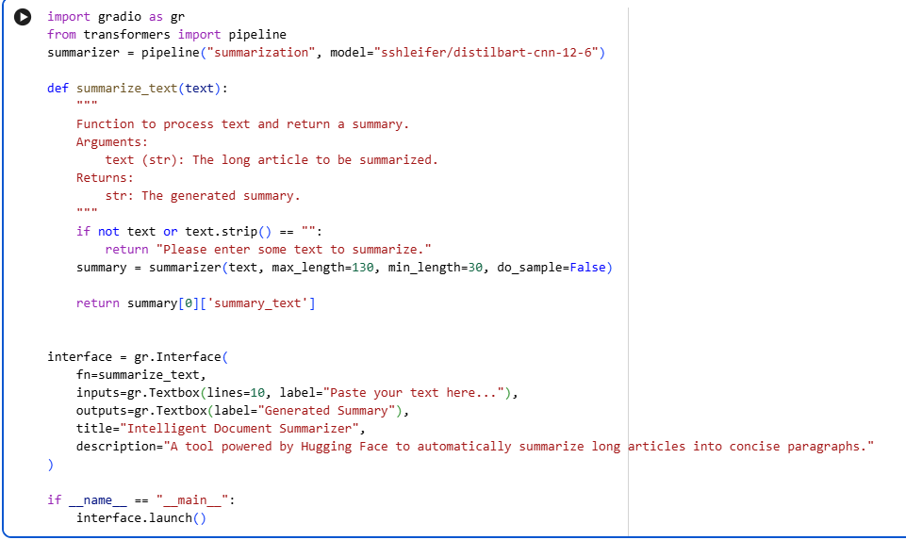

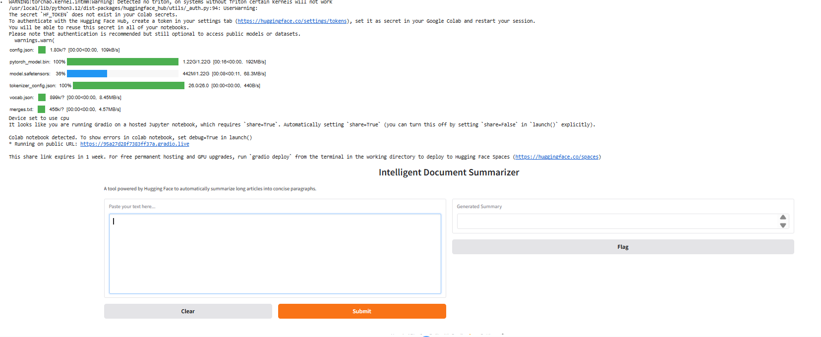
Code output :

